**1. Create an Oracle user and assign appropriate privileges for a schema that will support a unique e-Commerce application.**

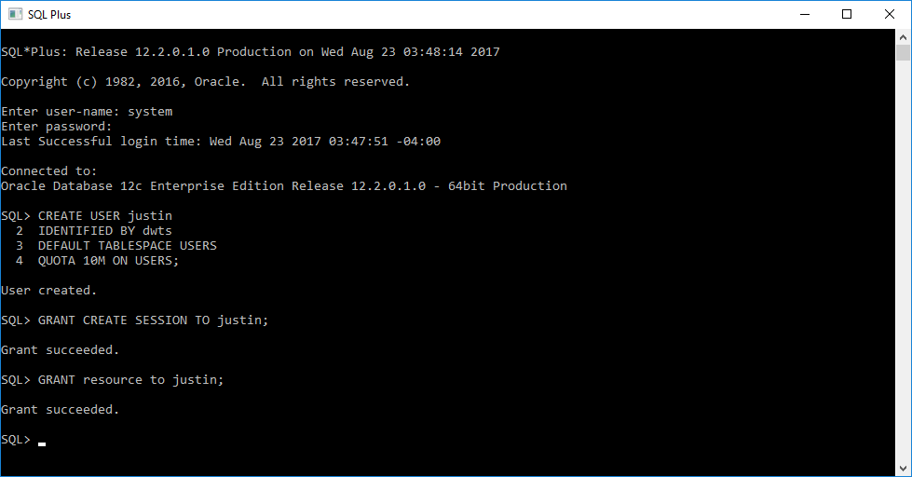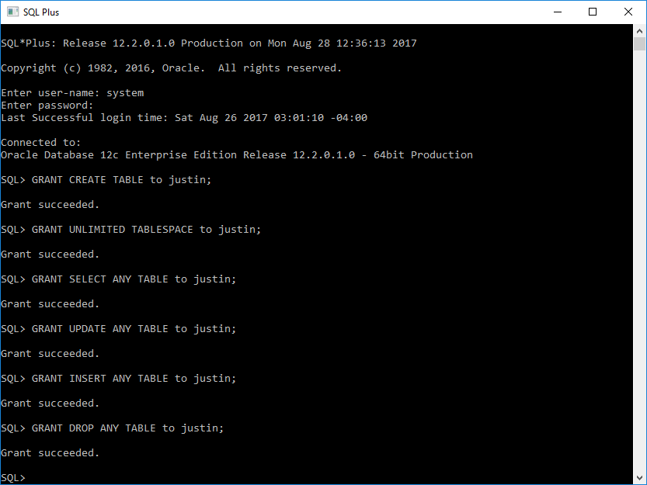

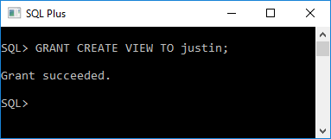

Logging in with the new user ‘justin’ that has been granted permissions by the system account.

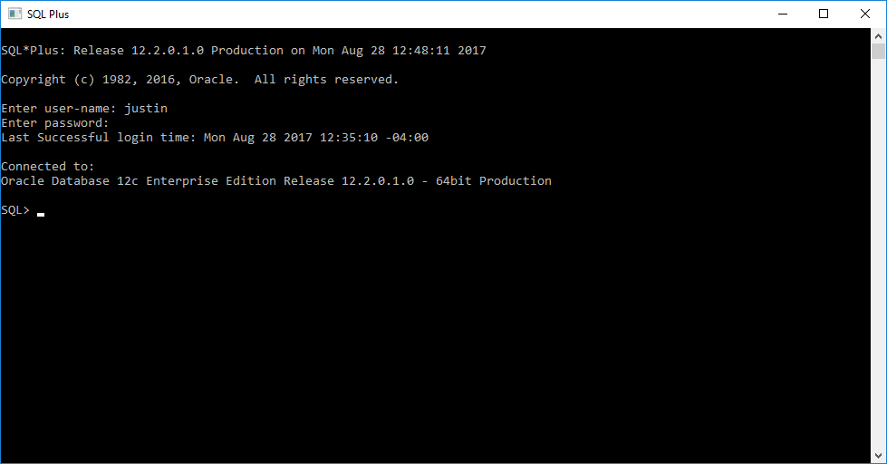

**2. Using PowerPoint, Visio or any graphical tool of your choice, create an Entity Relationship Diagram showing the entities, relationships and primary keys supporting your e-Commerce application. Your application should have at least four (4) entities. The total number of attributes across all entities should be at least fifteen (15). Be sure you use good database design that includes the use of Primary, Foreign, Not Null, and other constraints.**

Entity-Relationship Diagram description:

Note: Bold entities are required (NOT-NULL) and non-bold entities are not required (MAY BE NULL).

Each customer can have many forms of payment.

Each customer can have many orders.

Each order can consist of many products.

Each order can consist of many different types of payments.

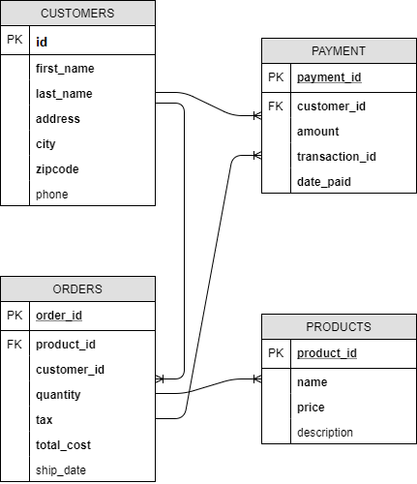

**3. Based on your design, create and describe each of your database tables. The tables must be created using SQL DDL statements along with all necessary primary key, foreign key and other integrity constraints. The tables should include comments describing each column that will be displayed using the appropriate Oracle data dictionary views. Perform both a DESC command to show the basic data about your tables' columns, and also perform a SELECT of the data dictionary to show the comments data you've added.**

Creating the customers, products, payment, and orders tables with Primary and Foreign Keys.

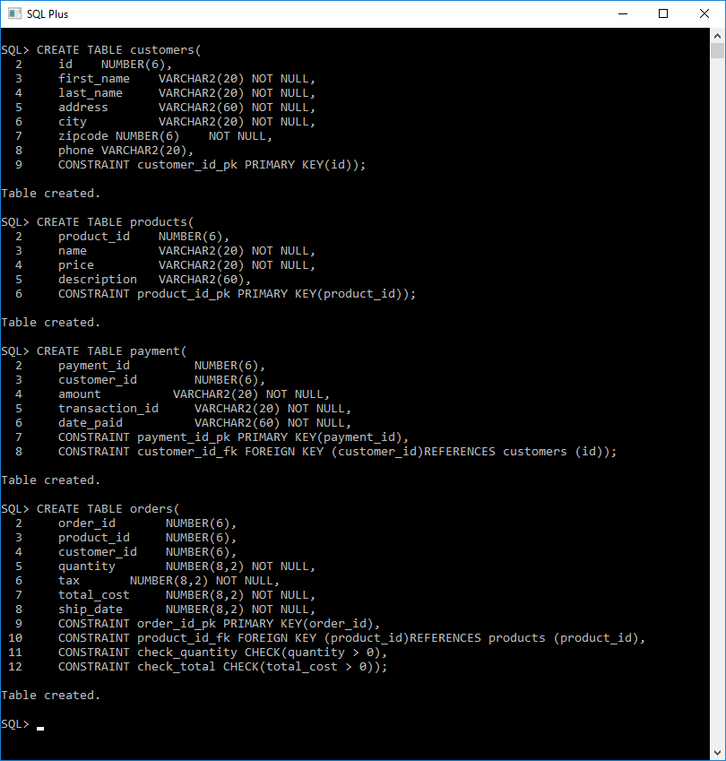

Creating comments for each table: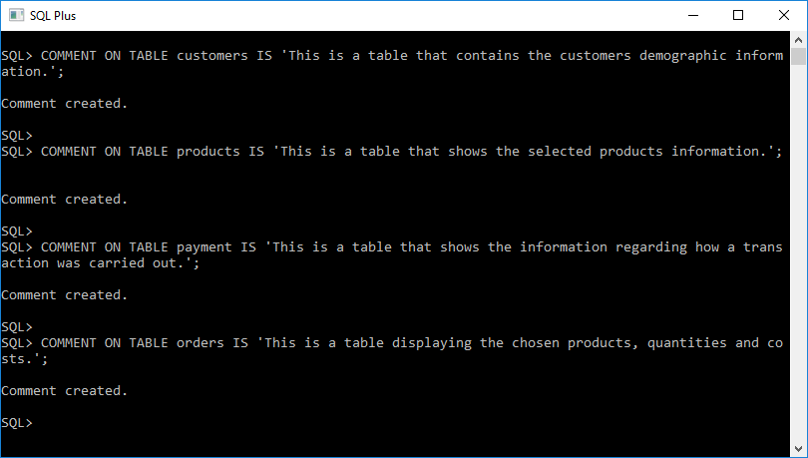

DESC command showing each newly created table.

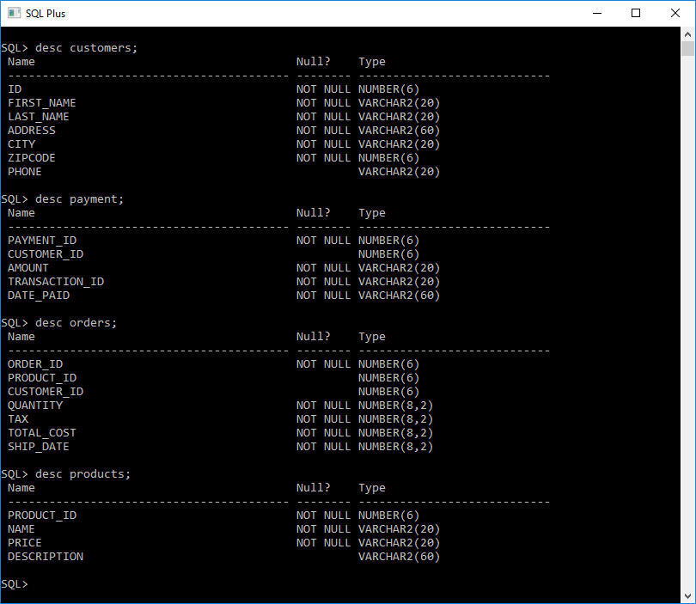

SELECT command showing each table and comments that have been added to each.

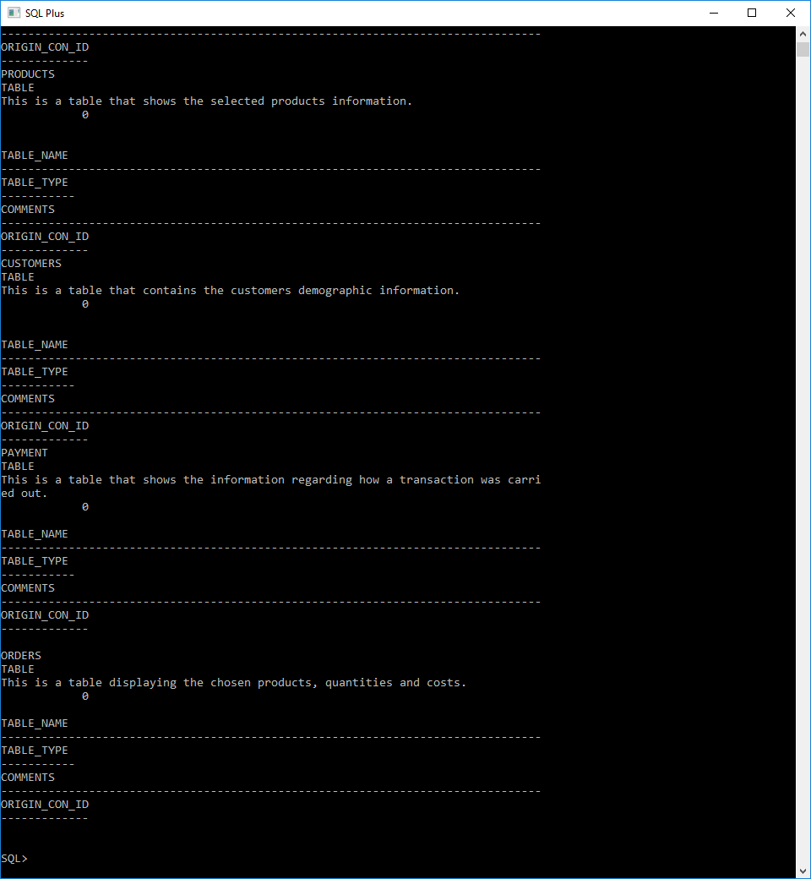

4. Populate your tables with records. The records should represent meaningful data and not placeholder data. You should populate at least 20 records total across all of your tables.

Populating the customers table:

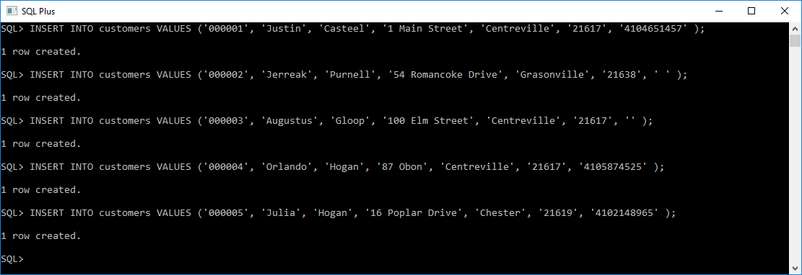

**Populating the products table:**

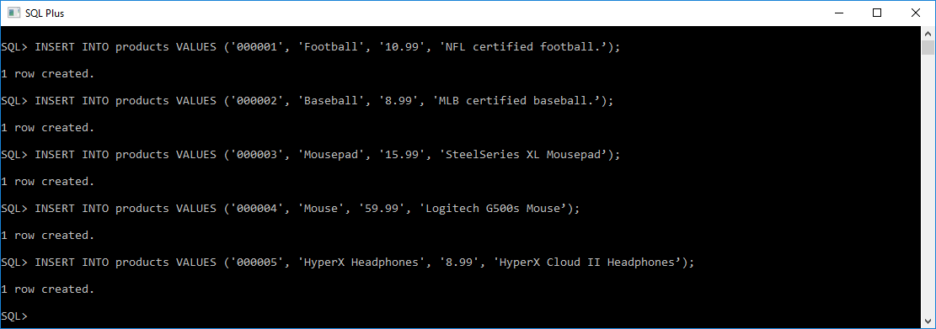

**Populating the payments table:**

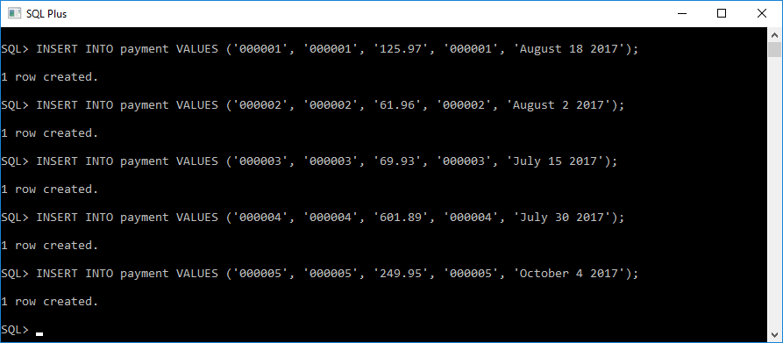

**Populating the orders table:**

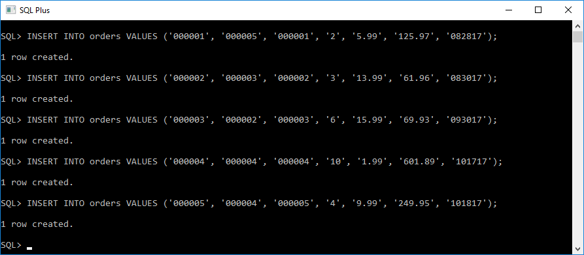

**5. Create one database view showing the combination of at least two tables resulting from a join. (Hint: Design and test the two-table join first, then create the view using the SQL join you just created (e.g., create view myView as select ... ))**

**Two-table join:**

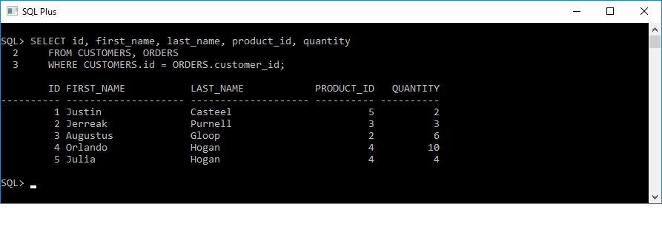

**Creating a view named customer_order for the customers and orders tables.**

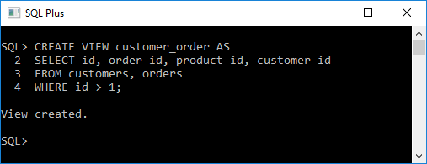

**Displaying the customer_order view that was just created:**

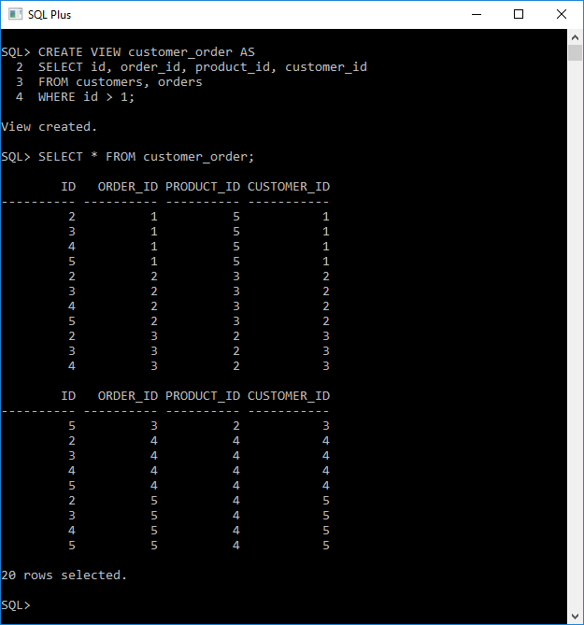

**6. Demonstrate your knowledge of select statements by creating at least six (6) queries that will return different data from your tables and view.**

**SELECT order_id, total_cost FROM orders;**

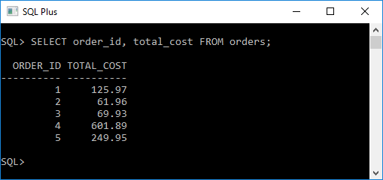

**SELECT * FROM customers WHERE ID = 2;**

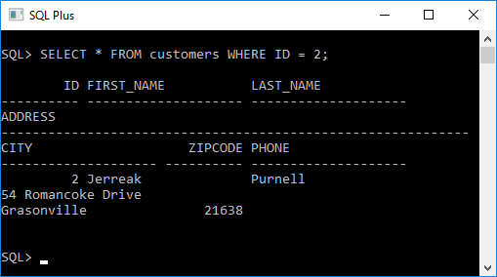

**SELECT quantity FROM orders WHERE quantity > 3;**

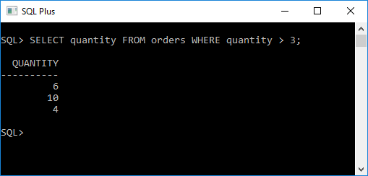

**SELECT * FROM customer_order WHERE ID = 3;**

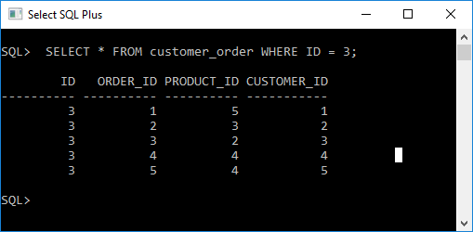

**SELECT * FROM customer_order WHERE product_id < 4;**

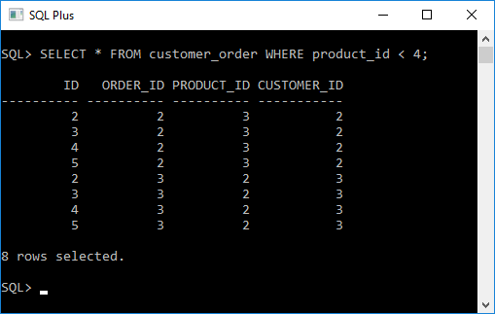

**SELECT * FROM customer_order WHERE product_id = 5 AND order_id = 1;**

